|  |  |
| --- | --- |
| **Module Name**  **Mechanical Testing Data** | **ID: D-MT-1** |
| **Due Date: See Canvas Assignment, Canvas Upload** |  |

**Mechanical Testing Protocol: – (Name & File ID of Protocol that this test data refers to)**

**Test Date –** 1/22/2020

**Roles:**

|  |  |
| --- | --- |
| **Technician: Your Name Here** | **Director: Your Name Here** |
| **Scribe: Your Name Here** | **Data Manager: Your Name Here** |

**Instructions**: Text in grey highlight should be revised based on your specific needs. There should be no grey highlighted text in your final deliverable, the highlights serve only to indicate regions that will likely need to be edited. This template serves only as an example document, revise to suit the given situation. **Delete this ‘Instructions’ paragraph prior to submission**.

**Machine Settings Defined in Mechanical Testing Protocol**

Machine Settings Section ID: ID

**Recorded Values – (Add reference to test name / ID if necessary)**

Here is example table, change this as appropriate based on your specific needs. This should not be raw data but rather a summary of the important values. Save raw data (hundreds or thousands of values) to a separate file if necessary, for example a csv file.

|  |  |  |
| --- | --- | --- |
| **#** | **Name / Description** | **After Img** |
| RV1 |  |  |
| RV2 |  |  |
| RV3 |  |  |
| RV4 |  |  |
| RV5 |  |  |
| RV6 |  |  |
| RV7 |  |  |
| RV8 |  |  |
| RV9 |  |  |
| RV10 |  |  |

**Raw Test Data – (Add reference to test name / ID if necessary)**

Here is example table, change this as appropriate based on your specific needs. Save raw data (hundreds or thousands of values) to a separate file if necessary, for example a csv file.

|  |  |  |  |
| --- | --- | --- | --- |
| **#** | **Filename** | **Location** | **Description** |
| TD1 |  |  |  |
|  |  |  |  |

**Graph(s) of Relevant Data**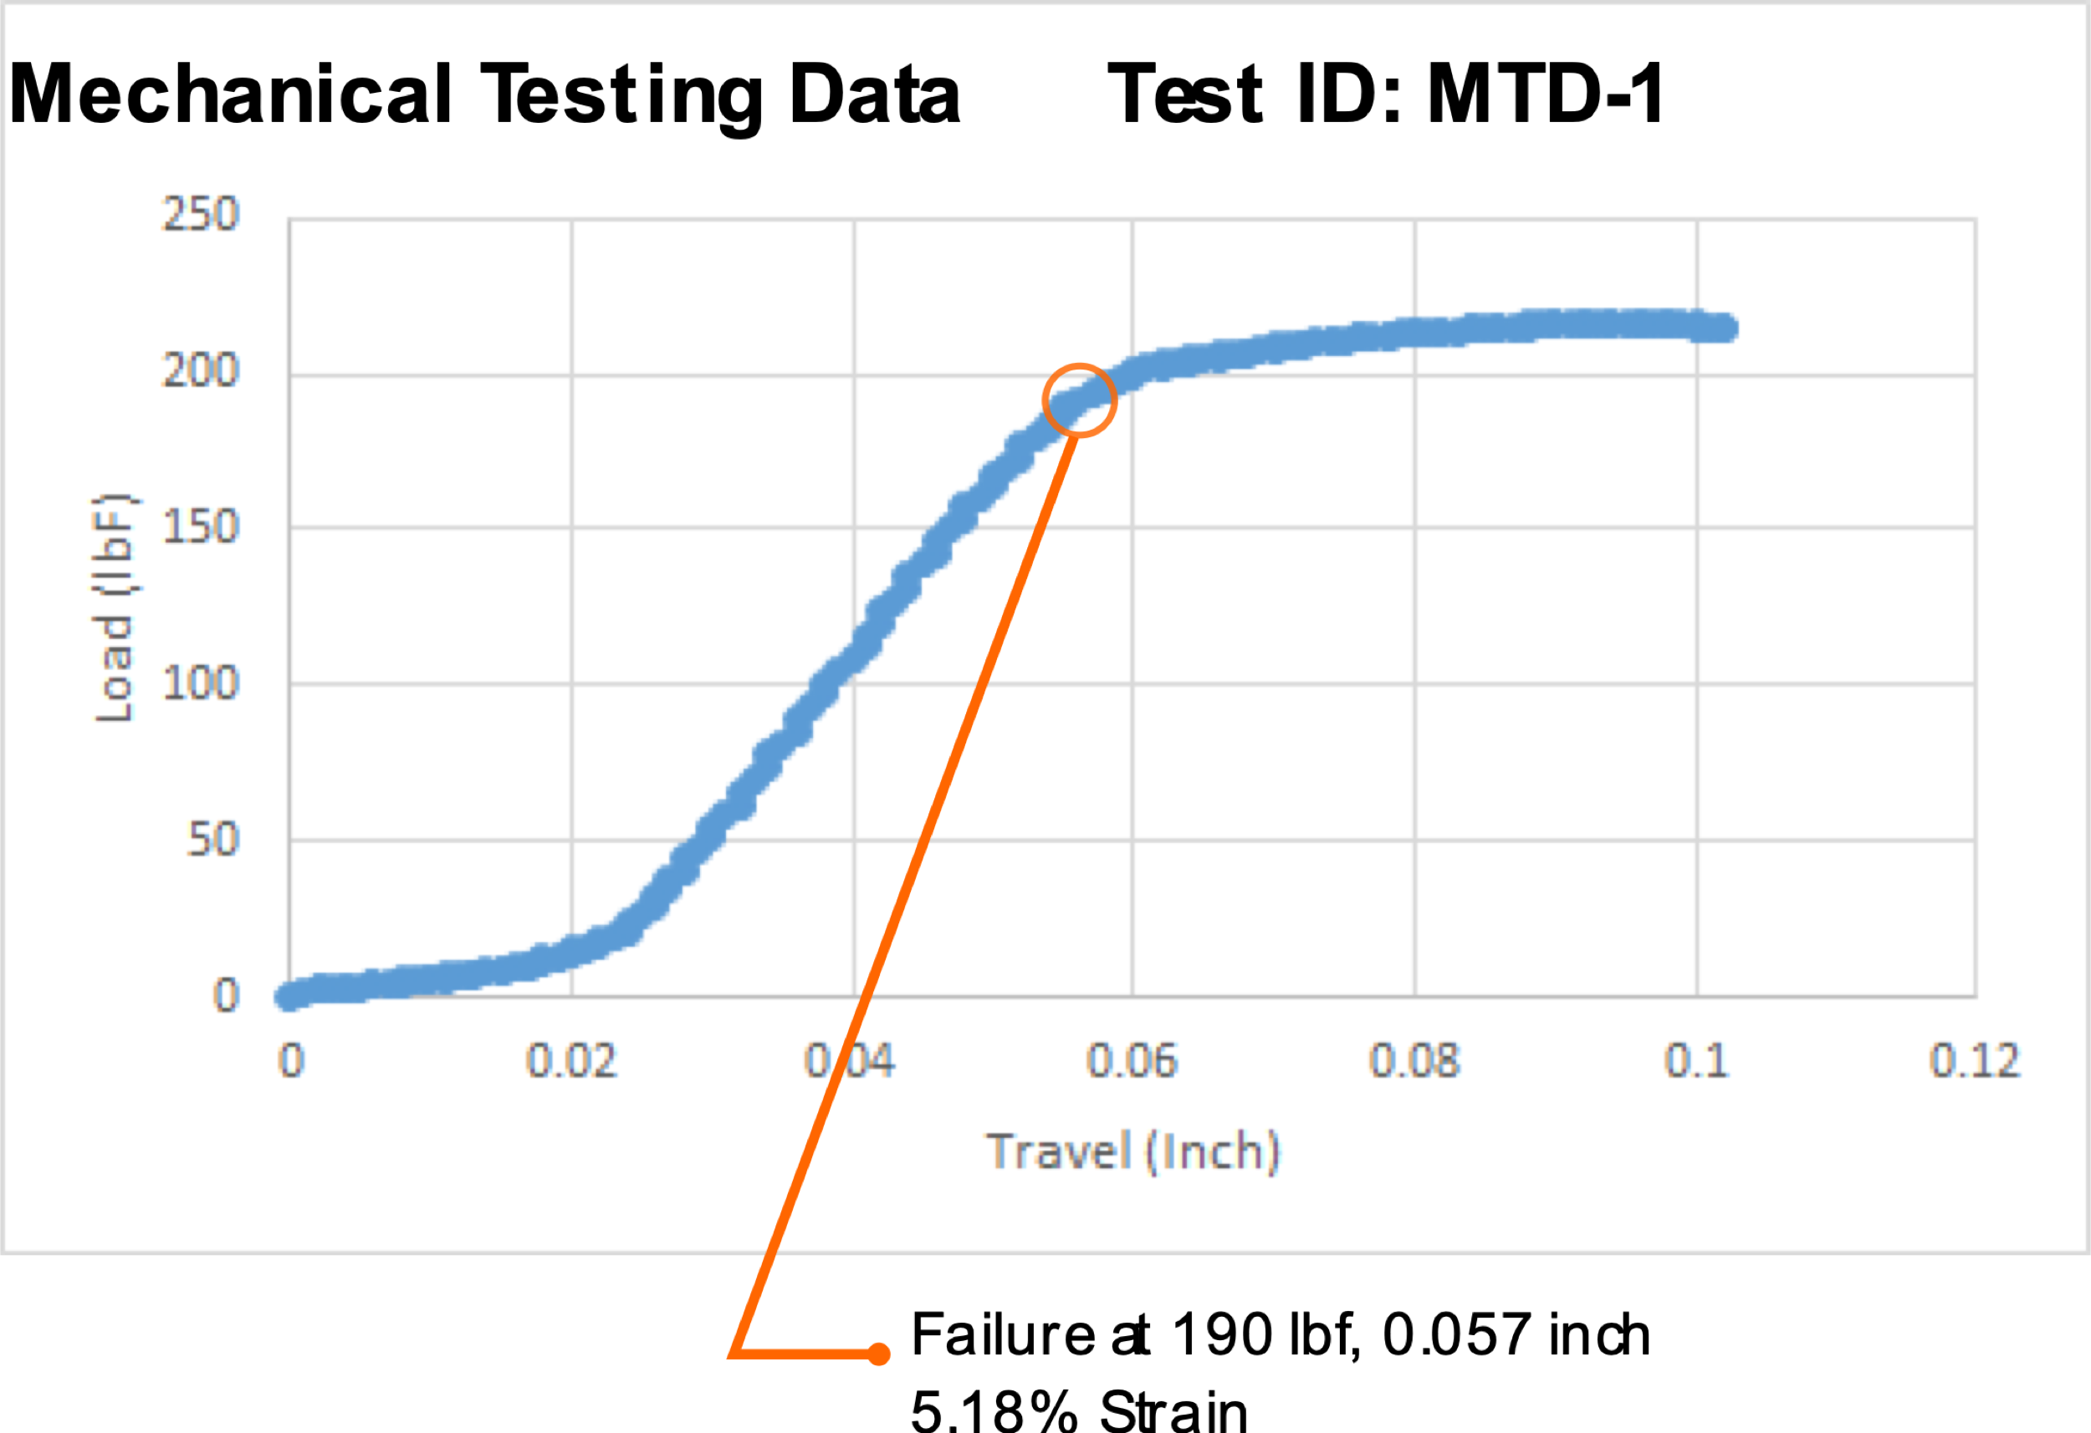

**Notes**